AIM:. To divide a given IP address block 14.24.74.0/24 into subnets based on host requirements.
An organization is granted a block of addresses with the beginning address14.24.74.0/24. The organization needs to have 3 subblocks of addresses to use in its three subnets as shown below:
a) One subblock of 120 addresses.
b)One subblock of 60 addresses.
c)One subblock of 10 addresses.
TOOLS/SOFTWARES REQUIRED: Cisco Packet tracer
THEORY:
IP subnetting is the process of dividing a large IP network into smaller, manageable sub-networks (subnets). It improves network performance, security, and efficient utilization of IP addresses.
In subnetting, an IP address is divided into two parts: the network part and the host part. By borrowing bits from the host portion, multiple subnets can be created based on the requirement of hosts in each network.
This experiment uses Variable Length Subnet Masking (VLSM), which allows creating subnets of different sizes according to the number of required hosts. Instead of assigning equal-sized subnets, VLSM helps in minimizing IP address wastage.
For a given network (14.24.74.0/24), subnetting is performed by:
- Calculating the number of host bits required for each subnet
- Assigning subnet masks accordingly
- Allocating IP ranges starting from the largest subnet to the smallest
Each subnet includes:
- Network address
- Usable host IP addresses
- Broadcast address
Subnetting ensures efficient IP address allocation and better network organization, especially in large networks.

OUTPUT:
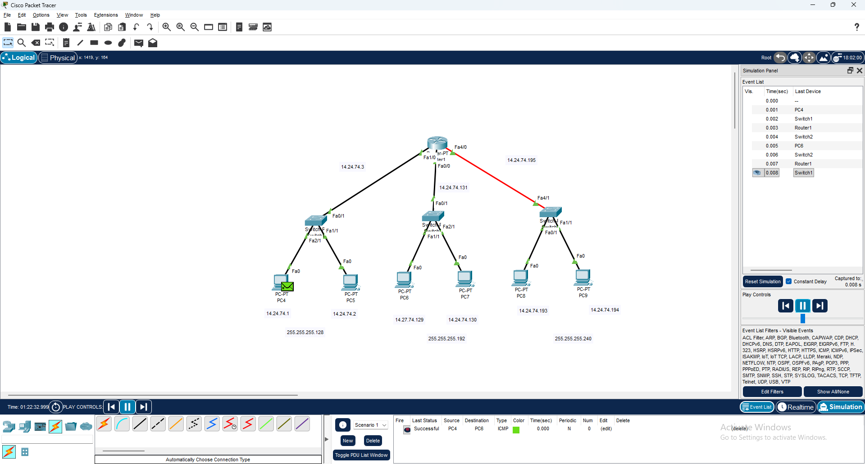

CONCLUSION:
Thus, the given IP address block was successfully divided into subnets based on host requirements using VLSM. The subnetting process ensured efficient utilization of IP addresses by allocating appropriate subnet sizes for 120, 60, and 10 hosts. This experiment demonstrated how subnetting improves network organization, reduces IP wastage, and enhances overall network efficiency.

